**EXPERIMENT 6**

**DML COMMANDS (COLLEGE SCHEMA)**

**Aim:**

* Insert 5 instances into the tables created in experiment 5.
* Display the tables.
* Add attribute course to student table then insert values.
* Use update to set course for students.
* Delete an attribute.

**Code:**

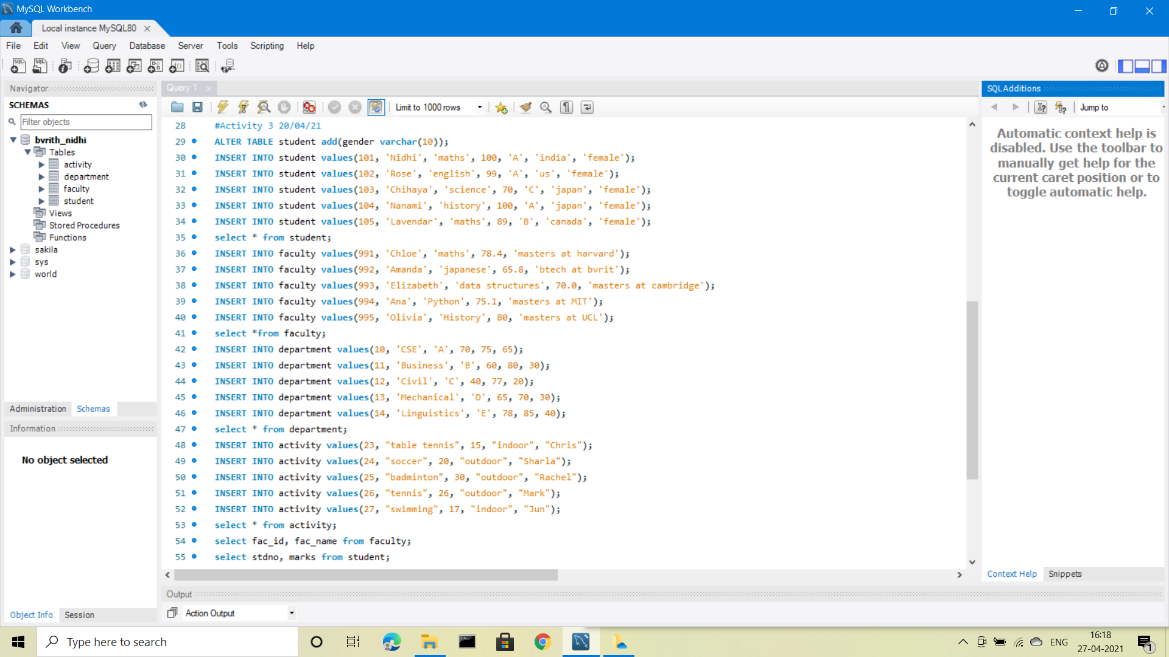

**Output:**

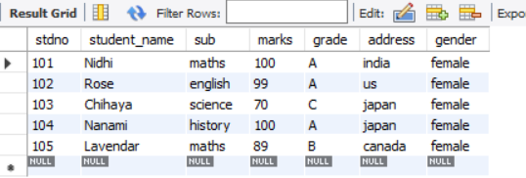 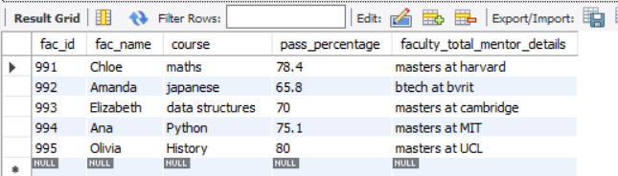

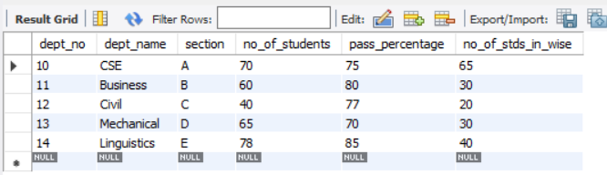 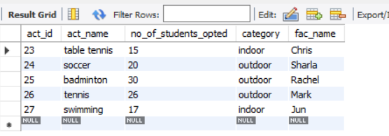

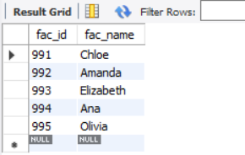 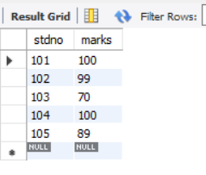

**Code:**

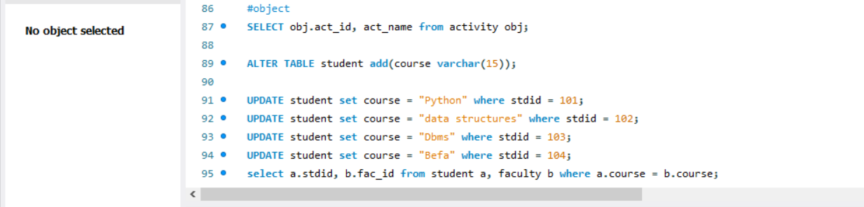

**Output:**

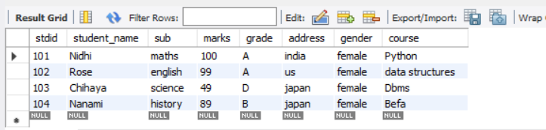

(Attribute is deleted in exp 5)